# Deploymnet of App in IBM Cloud Upload image to IBM Container Registry

|  |  |
| --- | --- |
| Date | 19November 2022 |
| Team ID | PNT2022TMID51917 |
| Project Name | Personal expense tracker application |

**Push the image to the IBM Cloud Registry**

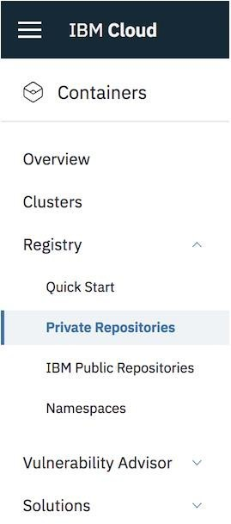

**Code**

ibmcloud plugin install container-registry -r "IBM Cloud" ibmcloud login -a <cloud_foundary_end_point_for_the_region> ibmcloud cr namespace-add <namespace>

ibmcloud cr namespace-add <namespace>

docker tag <image_name> <region_url>/<namespace>/<image_name>:<tag> docker push <region_url>/<namespace>/<image_name>:<tag>

ibmcloud cr image-list

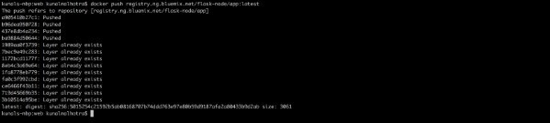

**deployment.yaml** apiVersion: extensions/v1beta1 kind: Deployment

metadata:

name: flask-node-deployment spec:

replicas: 1 selector: matchLabels:

app: flasknode template: metadata:

labels:

app: flasknode spec:

containers:

- name: flasknode

image: registry.ng.bluemix.net/flask-node/app imagePullPolicy: Always

ports:

- containerPort: 5000

**service.yaml** apiVersion: v1 kind: Service metadata:

name: flask-node-deployment spec:

ports:

- port: 5000

targetPort: 5000 selector:

app: flasknode

# Deploy your application to Kubernetes

